**User manual**

Step 1: - Open any browser and navigate to <https://dge.msbae.in/>

Step 2: - The landing page will appear After navigation to the above URL as in below picture

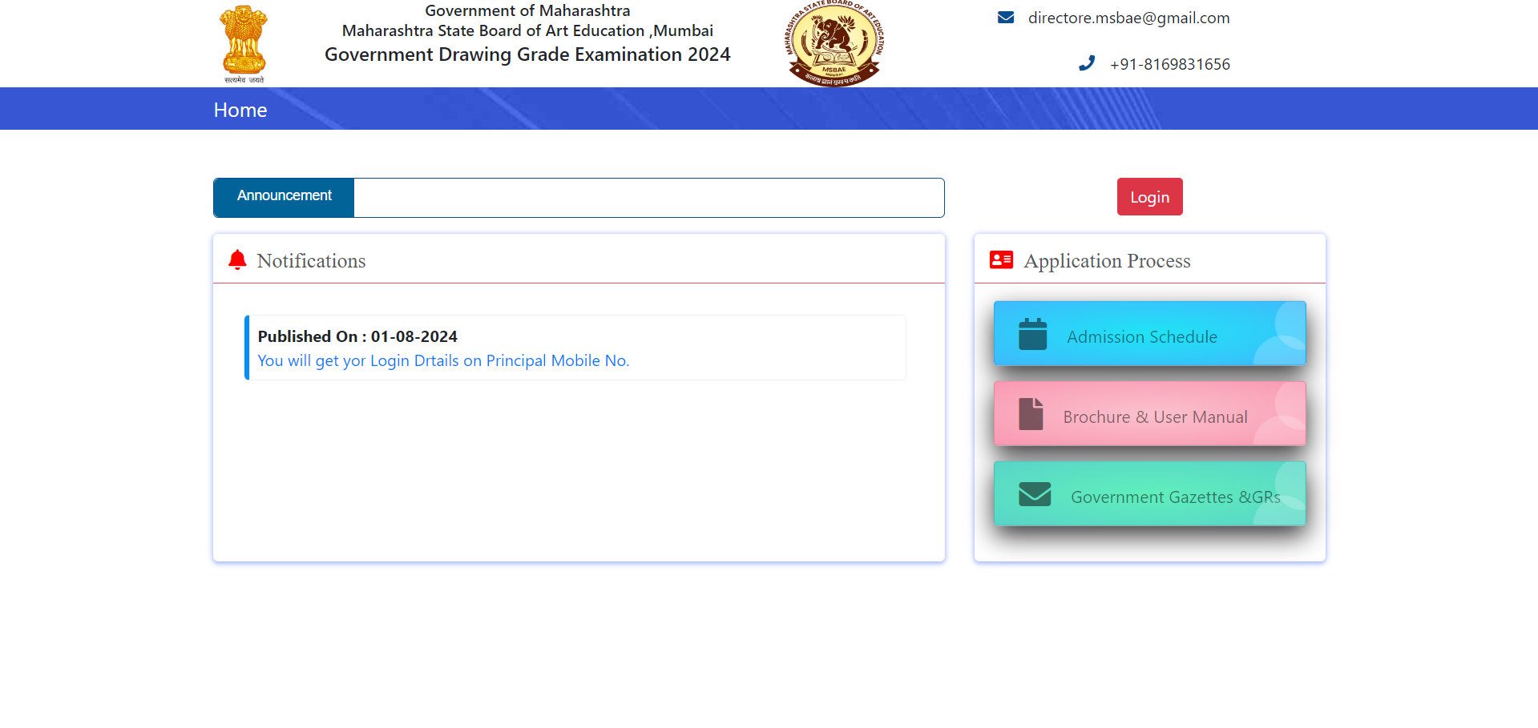

Step 3: - On landing page you can see the Notification section, in this section the user can see the all the uploaded notification published by Government Drawing Grade Examination.

Step 4: - In order to Login as Center Admin, user have to click on Login button as shown in below picture.

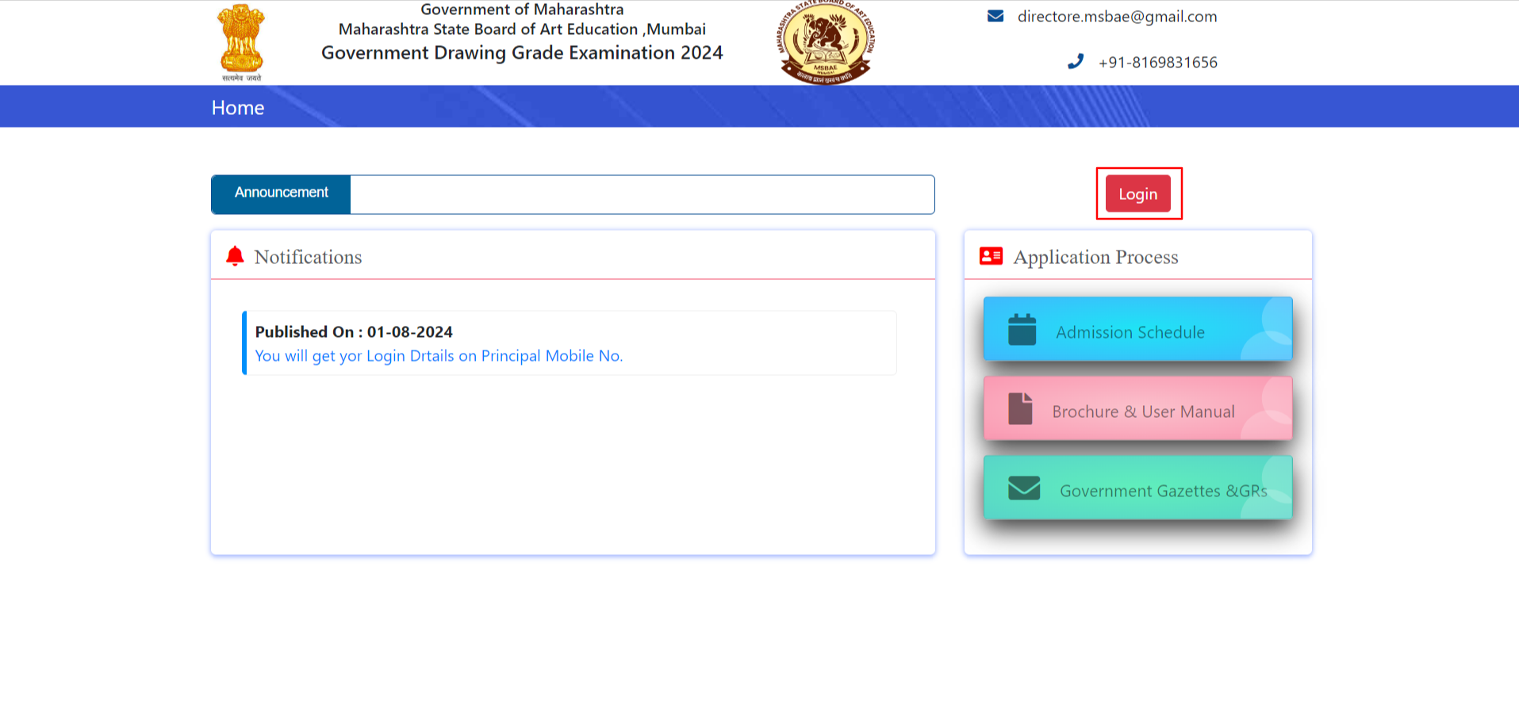

Step 5: - After clicking on Login button, login page will appear on this page enter username, password and click on Sign In button.

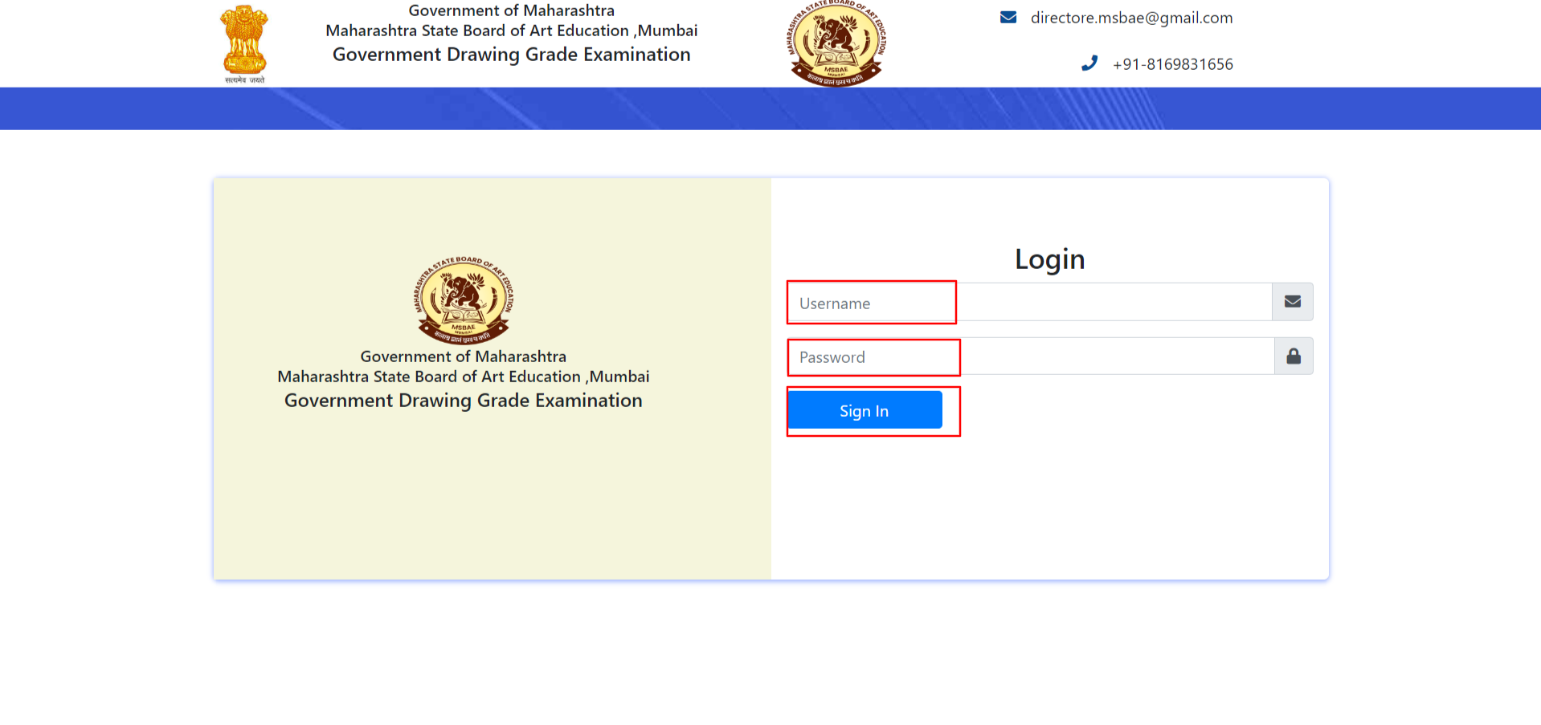

Step 6: - Once you logged in successfully, user have to rest the password, the Reset Password page will appear enter the password in New Password and Confirm password field as in Password Requirements format and click on Update Password button.

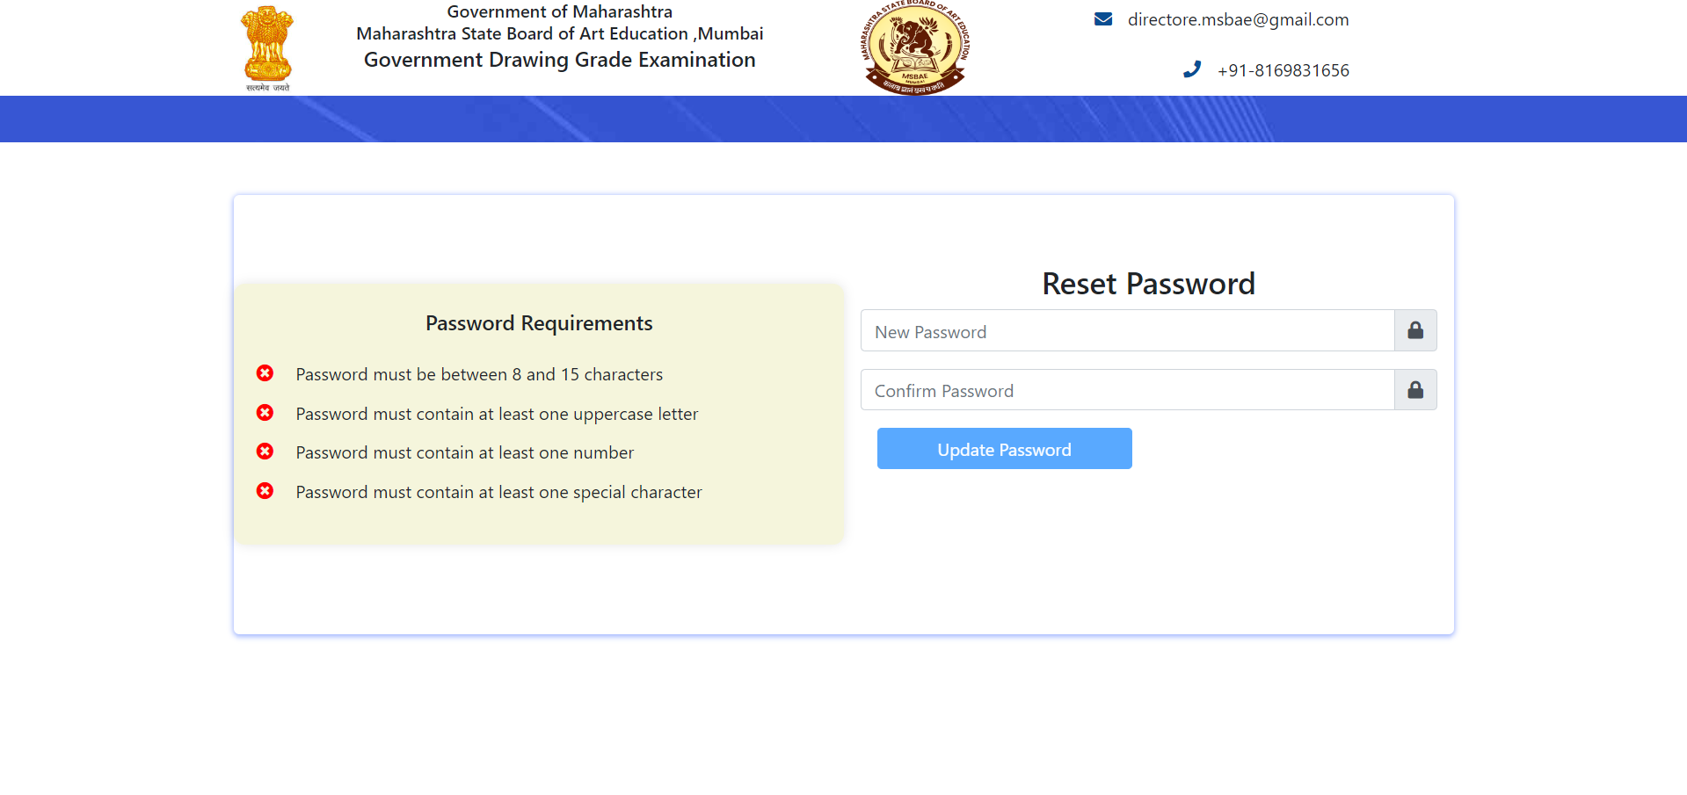

Note: - Reset Password page will for first time only. Once you reset the password this page will not appear.

Step 7: - Now the user will navigate to Home page as in below picture

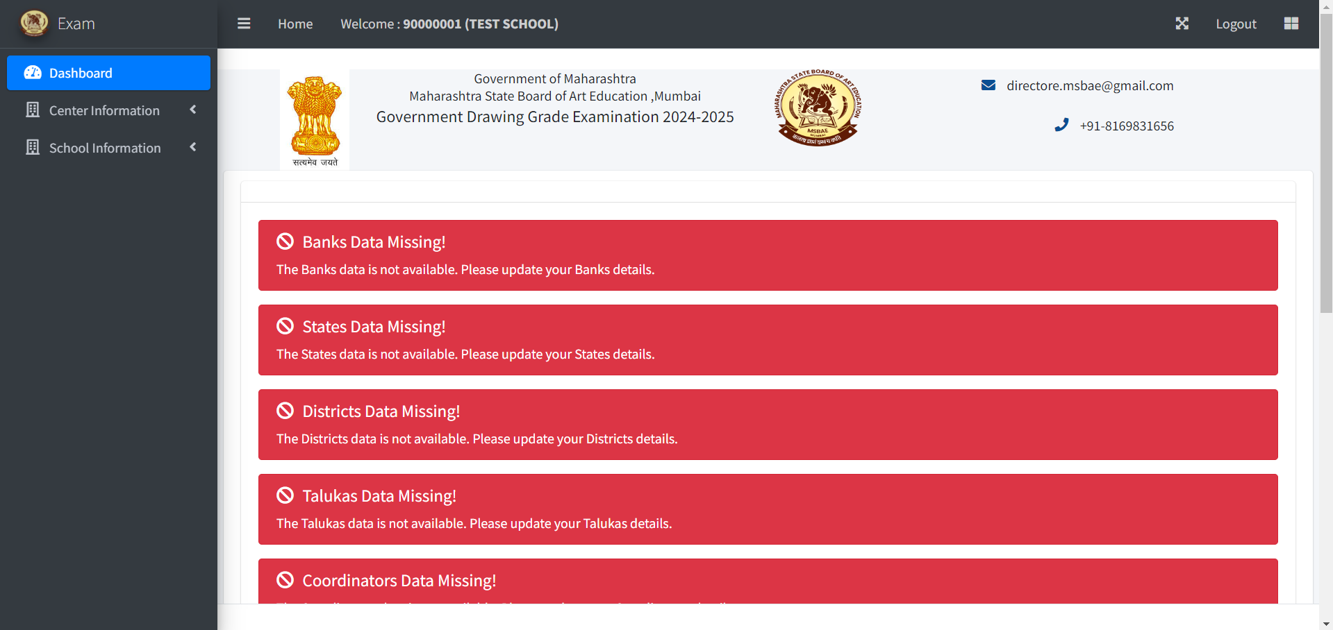

Step 8: - On Home page the missing data labels are available, in order to update the missing data, user have to click on Center Information link available in menu link then click on View Center Information link. The information page will appear as in blow picture.

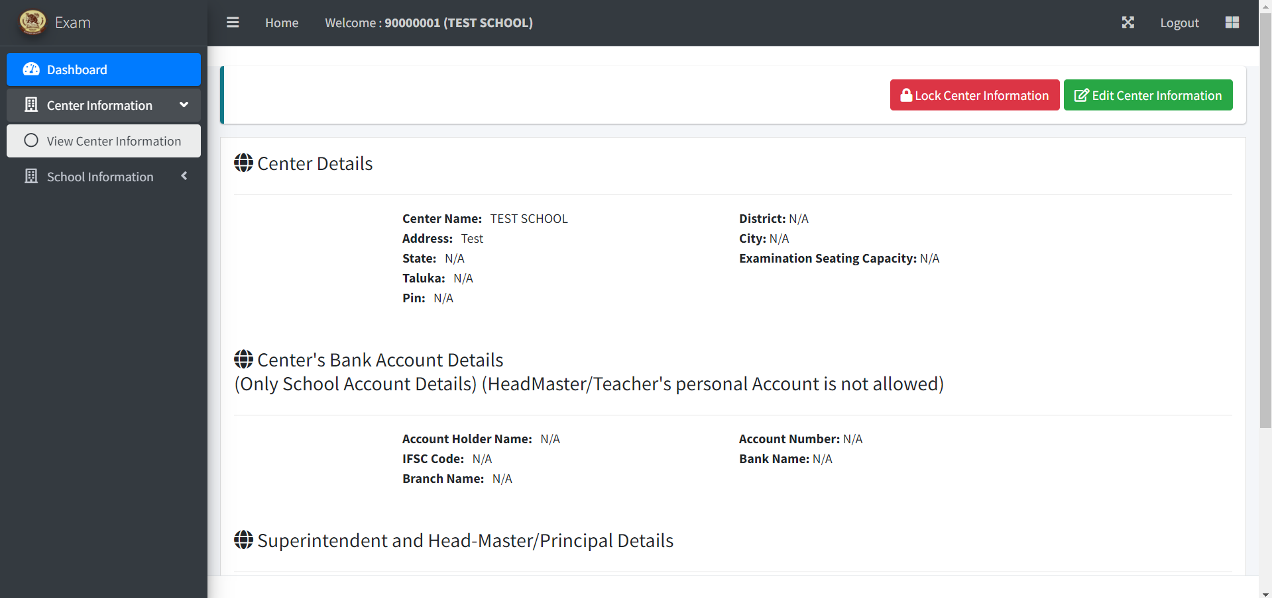

Step 9: - To update the Center information, click on the Edit Center Information button and then click on the Yes, Edit button, Update the info and click on the Update button you will get a success message of Update.

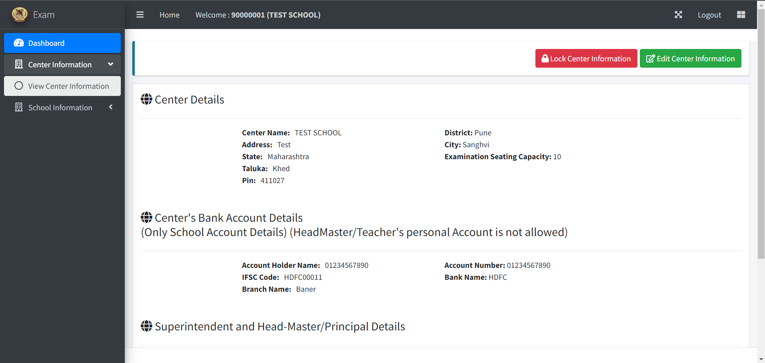

Step 10: - To Add New School, click on the School Information link from menu then click on the Add New School link now user can navigate to Add New School form as in below picture.

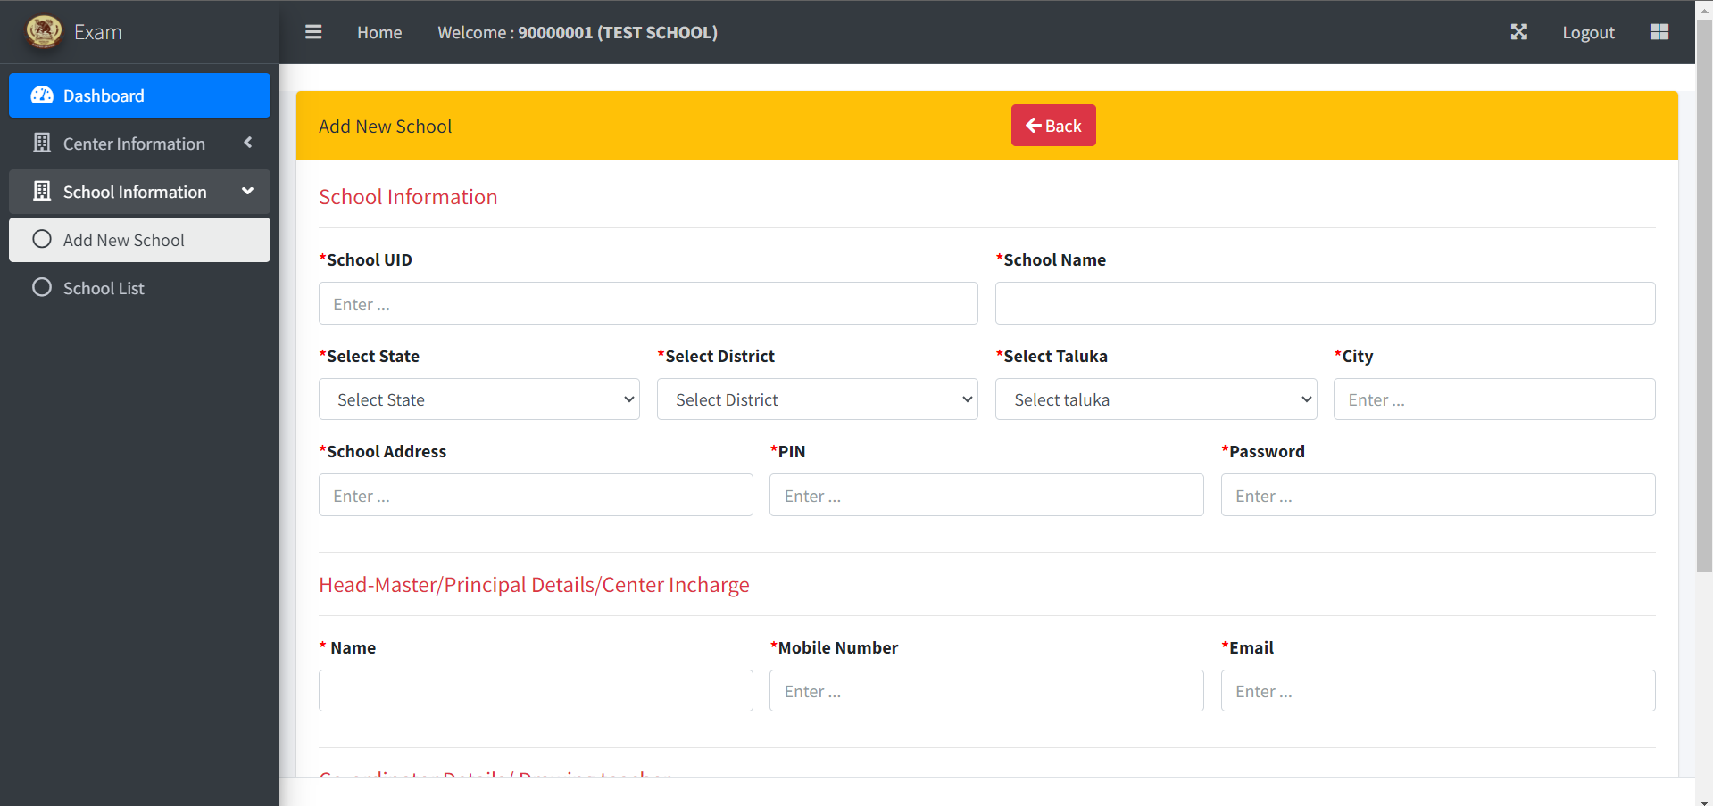

Step 11: - Enter the appropriate data and click on the Save button, once you click on the save button success message will appear if not then the form is popped with the warnings, update the correct data and click on the Save button.

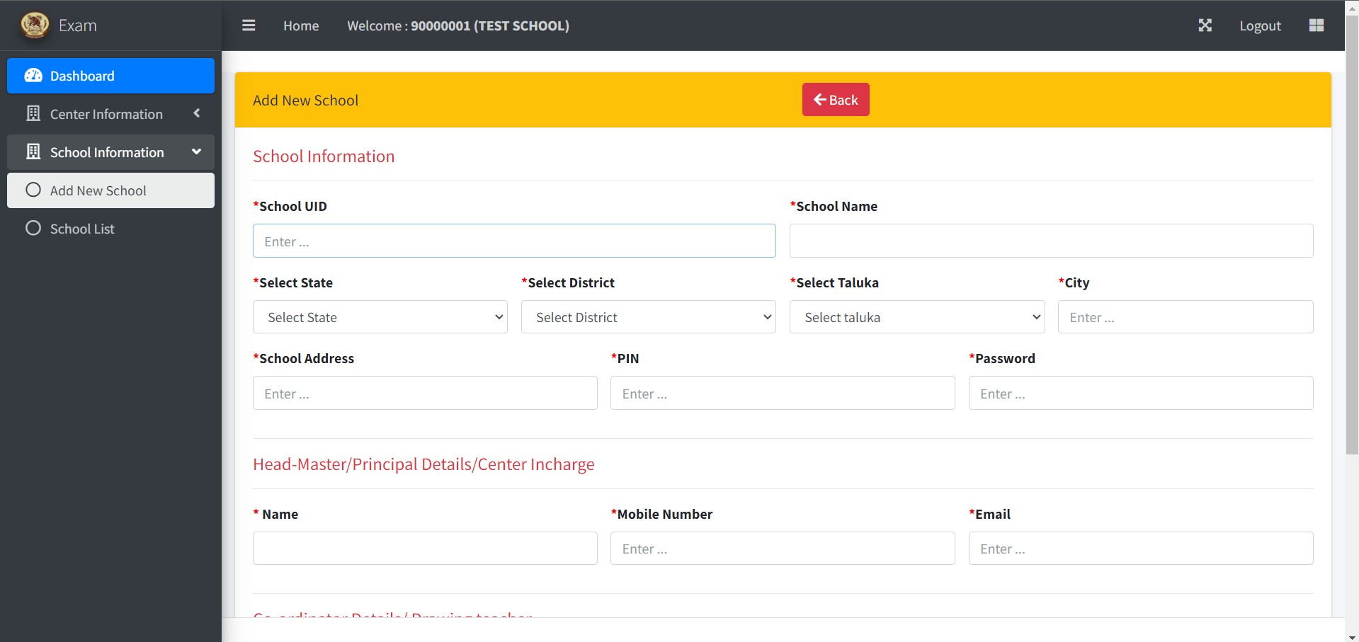

Step 12: - Once you done with adding new schools, to check the added schools list click on the School List link the school list page will appear as in below picture

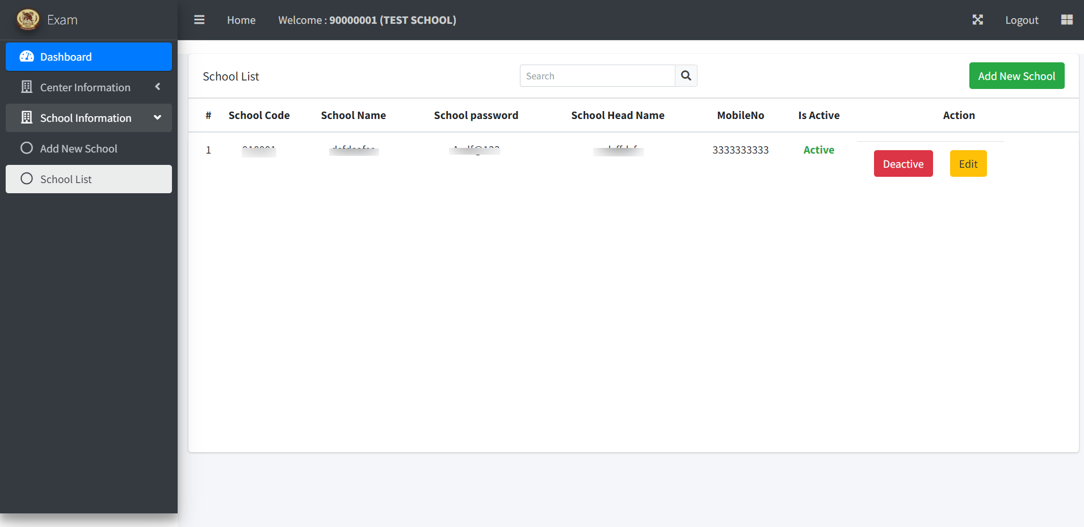

Step 13: - On this page user can see the Add New School button at right side of the page to add school follow Step 12, You can also edit and deactivate the school login by clicking on the appropriate button.

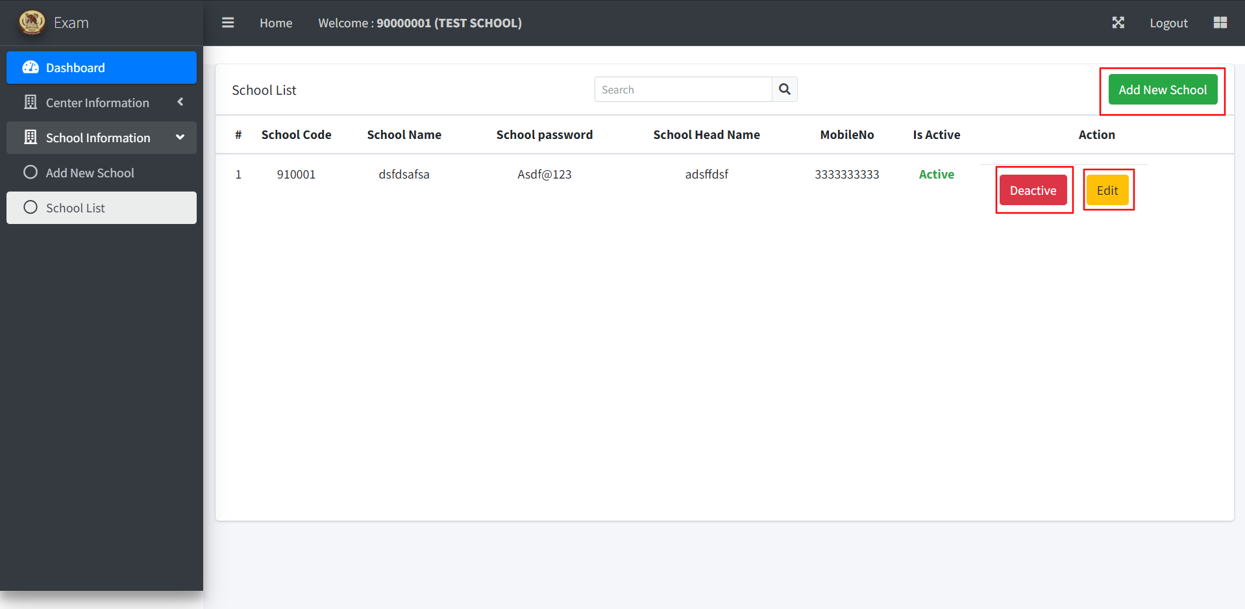

To edit the school information, click on Edit button of the school which is available in the row of school name, when you click on the edit button you will navigate to edit school information page, fill-up all the data and click on the Update button the success message will appear.

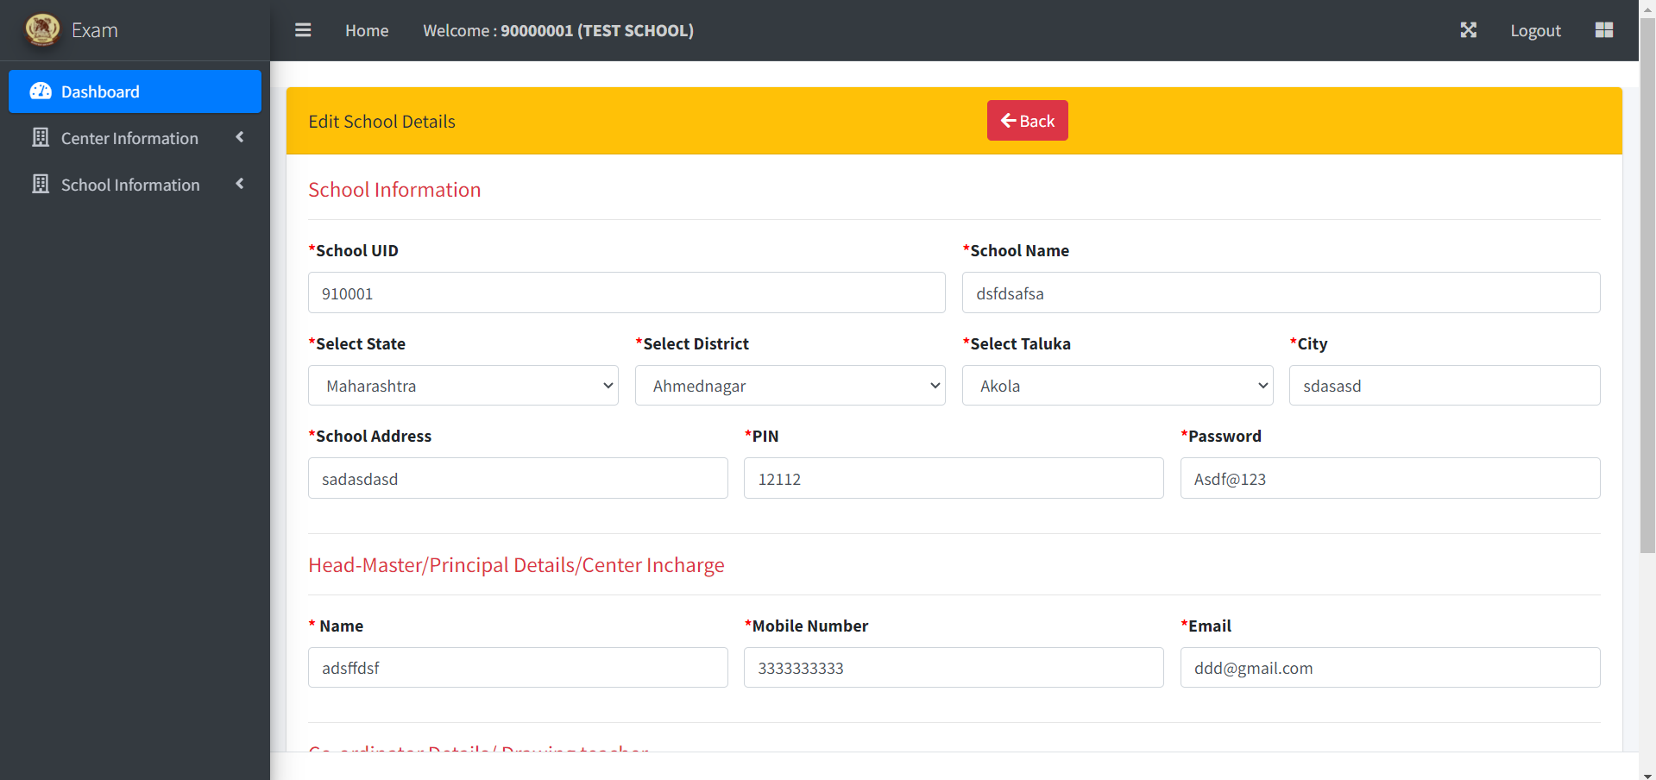

To deactivate the school login, click on Deactivate button, once you click on the button the button turns to Active and the success message as in below picture.

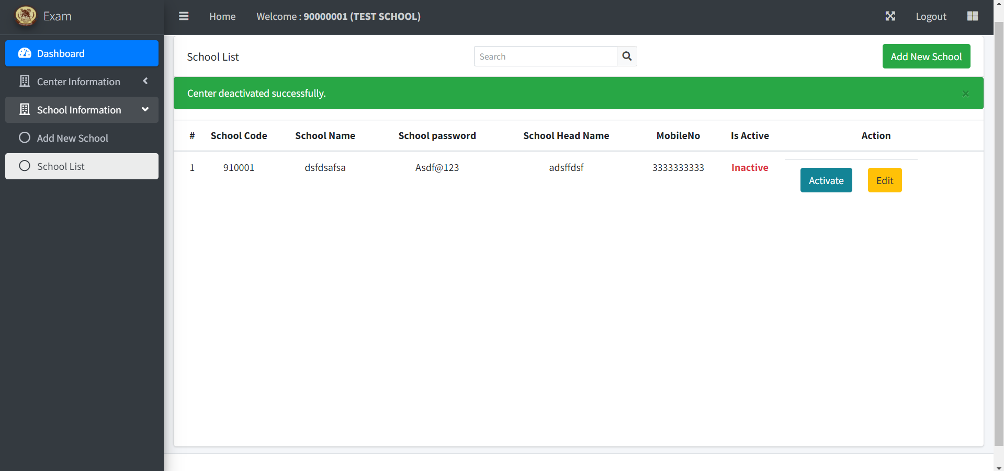

Step 14: - Once you update all the information of school and center the missing data labels are invisible and now you will see the dashboard with the data labels as in below picture.

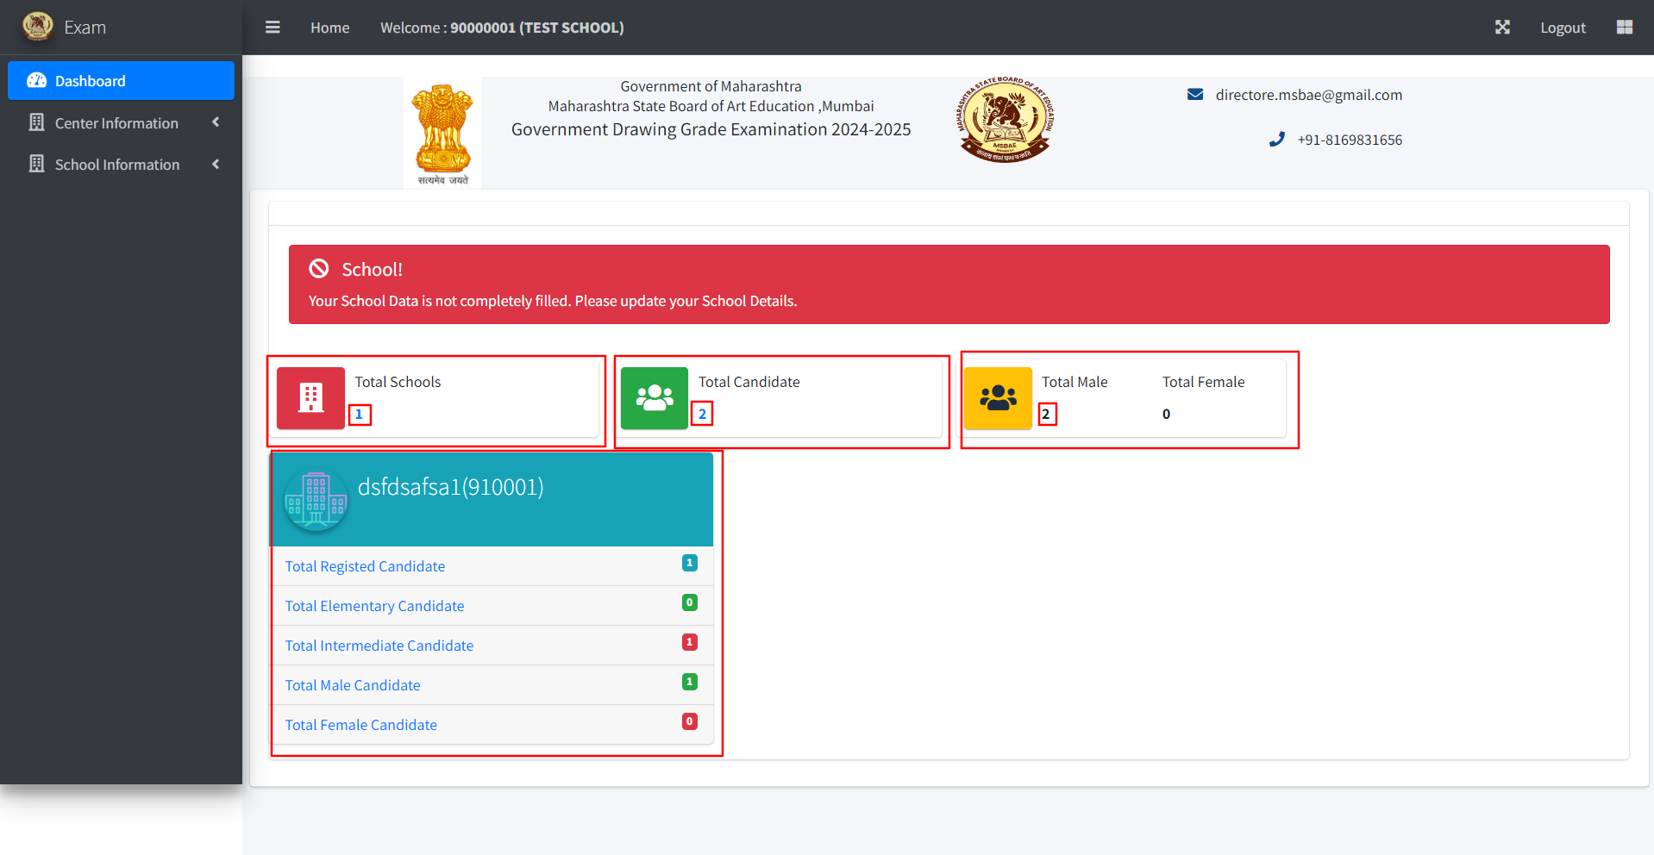

Total Schools label: - You can see the count of added schools; in order to see the list click on the school count, you will navigate to school list as shown in Step 13.

Total Candidates label: - You can see the count of added candidates from the school login, in order to see the list click on the candidates count the list of candidates page will appear as in below picture.

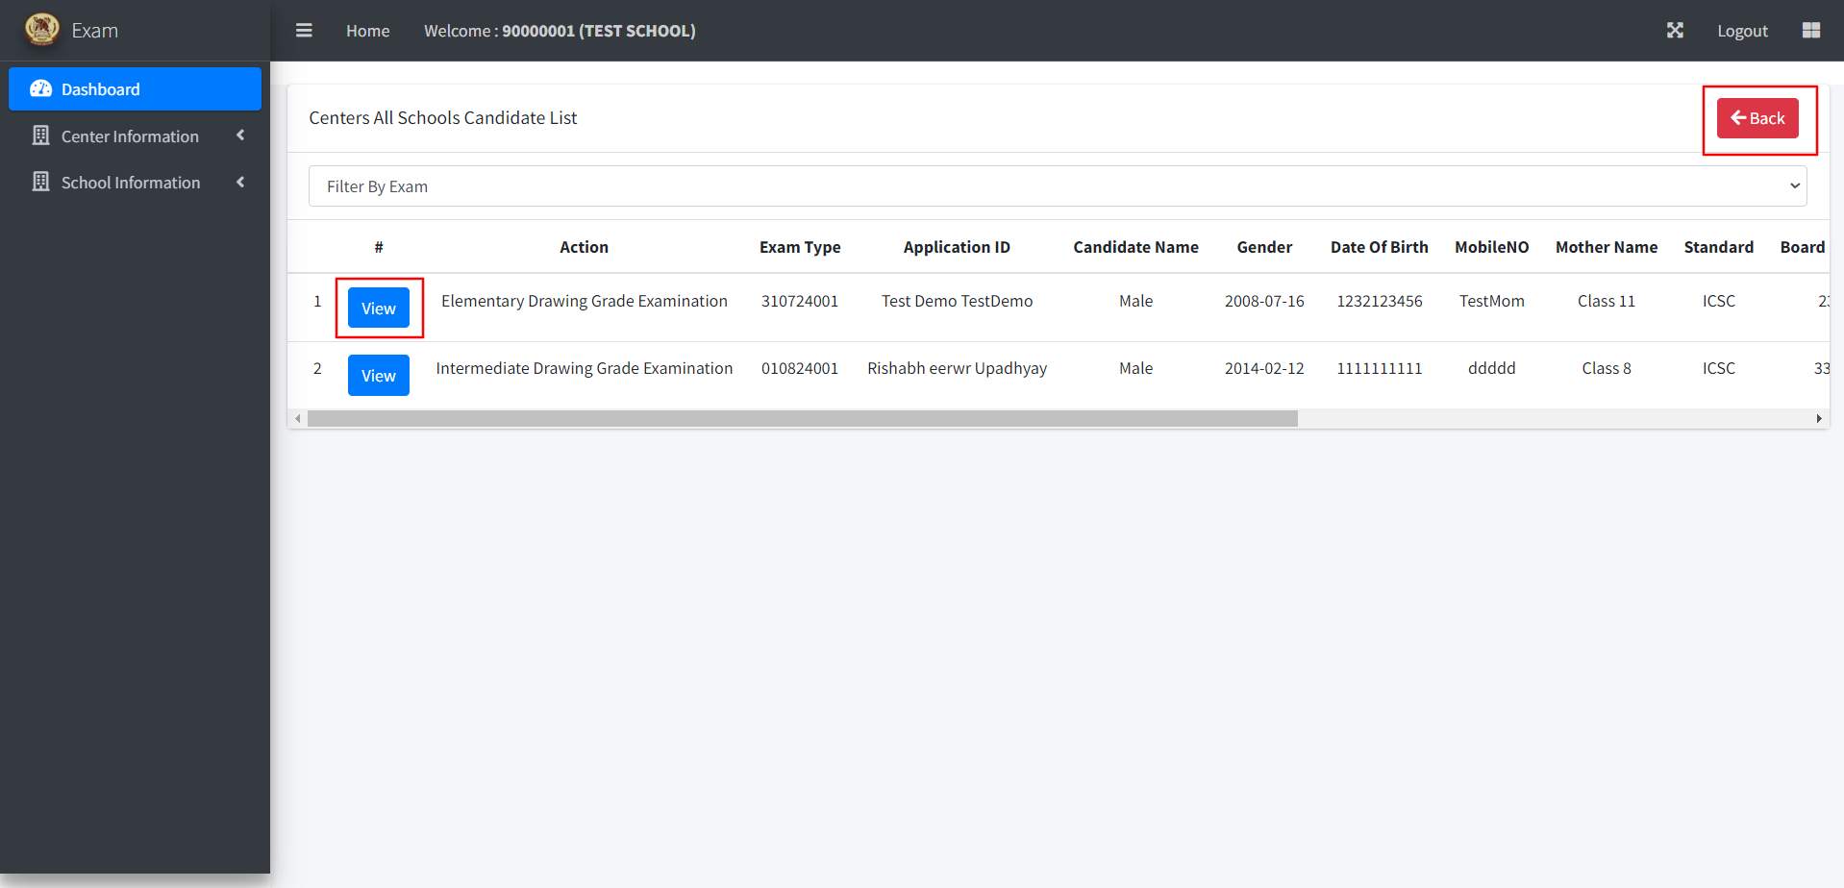

1. Click on the Back button to navigate to Dashboard
2. Click on View button to view the student details page as in below picture.

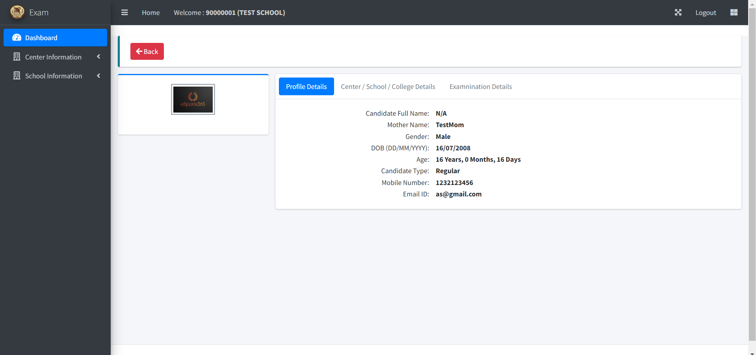

On Dashboard page you can also view the candidates count gender wise as shown in Step 14.

Step 15: - In order to logout the user click on the Logout button available at right side upper corner as shown in below picture. Again, you will navigate to landing page.

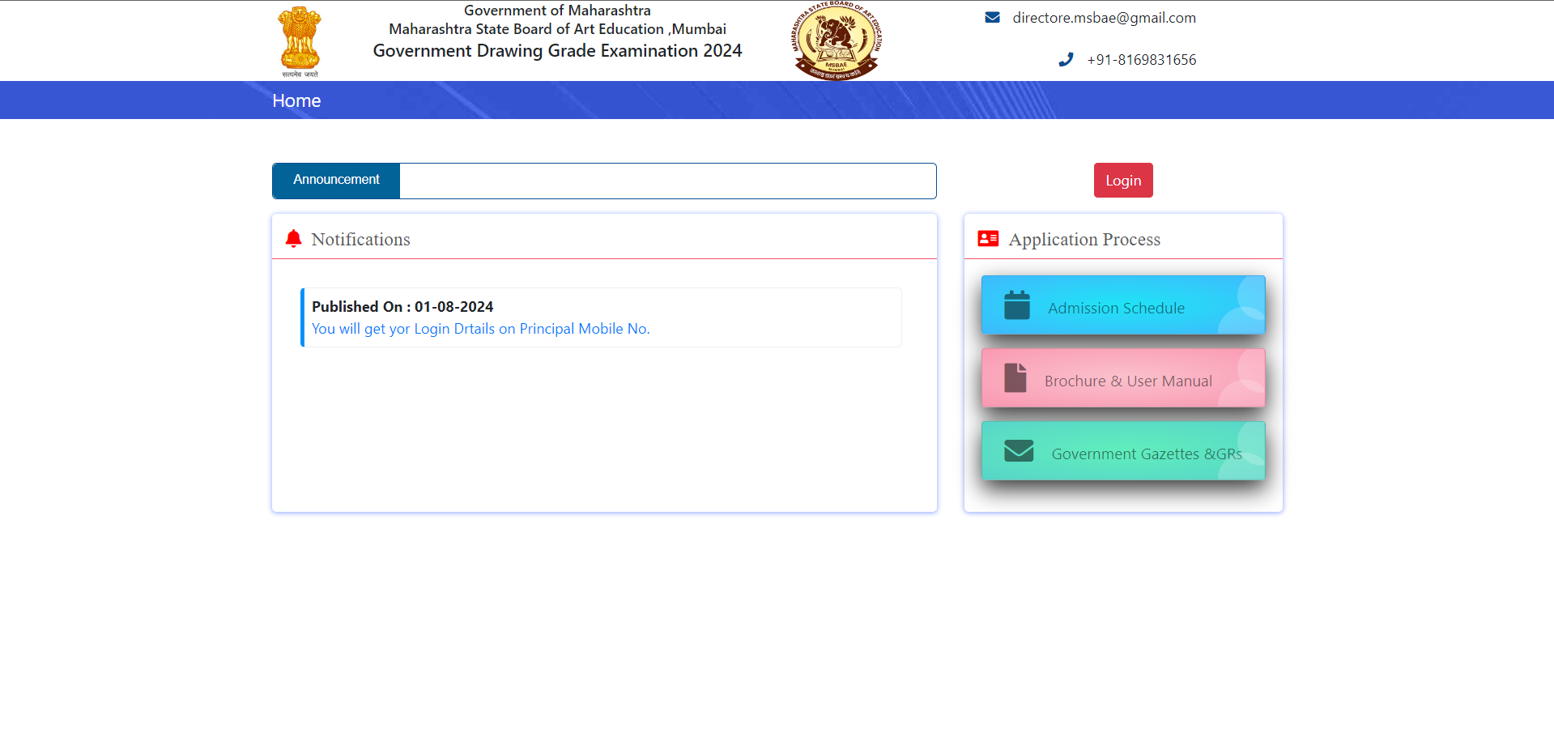

Thank You..